Chapter 19, Problem 68.

Obtain the h parameters for the network in Fig.19.115.

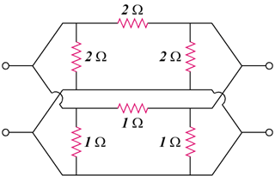

Figure 19.115
For Prob. 19.68.

